The Representation of Solutions of Burger’s Equation by Finite Difference Method and It’s Applications
A Project report
Submitted to Department of Mathematics, University of Chittagong
In partial fulfillment of the requirements for the degree of Master of Science
Session: 2021-2022
Course code: Math 535



Submitted by:
Name: Saheb Anik Paul
Student ID: 18203066

Under the supervision of
Parvin Akter
Assistant Professor
Department of Mathematics
University of Chittagong
Date of Submission: 4th February, 2025

Acknowledgement

I express my heartiest gratitude to the almighty Allah, the most beneficent and merciful.
I respectfully express my gratitude and indebtedness to my supervisor, Parvin Akter, Lecturer, Department of Mathematics, University of Chittagong for his instruction, valuable advice, suggestions and encouragement throughout the period of this research study.
I also express my gratitude to all the other respected teachers in my department for their support and encouragement during the period.
I would like to express my thanks to my family, friends and everyone from Department of Mathematics who has continuously supported us through my memorable journey at University of Chittagong.

Certification

This is to certify that the project entitled “The Representation of Solutions of Burger’s Equation by Finite Difference Method and It’s Applications” submitted by Saheb Anik Paul (ID: 18203066), to the University of Chittagong, for the partial fulfillment of the requirement for the degree, in Master of Science in Applied Mathematics is a bona-fide record of the project work carried out by them under my supervision. No part of the project has been submitted for any other degree or diploma.

---------------------------------------
Parvin Akter
Assistant Professor
Department of Mathematics
University of Chittagong

Abstract
This study explores both numerical and analytical solutions of the Burgers' equation using the finite difference method, specifically applying the explicit scheme. As a fundamental partial differential equation in fluid dynamics and nonlinear wave theory, the Burgers' equation provides an important test case for evaluating numerical techniques and stability considerations. For the analytical solution, we utilize the travelling wave approach, which accurately describes shock formation and wave propagation. Numerical simulations were implemented in MATLAB for the first time, where the explicit finite difference method was compared against the analytical solution. The resulting graphs demonstrated a strong correlation between the two approaches, affirming the accuracy of the numerical method.
Furthermore, an in-depth stability analysis was performed to ensure the dependability of the numerical scheme. By satisfying the stability criteria of the explicit method, the results consistently converged, verifying that this approach is suitable for solving the Burgers' equation under the given conditions. This research underscores the significance of numerical techniques in solving nonlinear partial differential equations and confirms the explicit finite difference method as an effective tool for approximating such solutions. The findings contribute to the advancement of numerical methodologies for nonlinear equations and can serve as a basis for future research in computational fluid dynamics and applied mathematics.

Table of Contents

 | Acknowledgement
 | Certification
 | Abstract
 | Table of contents
1. | Introduction | 6
2. | Classification of Differential Equation | 7
3. | Nonlinear Partial Differential equation | 10
4. | Application of Burgers Equation | 12
5. | Exact Solution of Burgers Equation | 15
6. | Numerical Solution of Burgers equation | 16
7. | Stability Analysis of the Explicit Method | 18
8. | Comparison between analytical and numerical solution | 21
9. | Code for analytical solution of Burgers equation | 23
10. | MATLAB Code for numerical solution of Burger’s equation | 26
11. | Results and discussion | 29
12. | Concluding Remarks | 31
13. | References | 32

- Introduction
The Burgers equation is a key partial differential equation with applications spanning various fields such as fluid mechanics, nonlinear acoustics, traffic flow, and gas dynamics. It provides a simplified framework for studying complex phenomena, including shock wave formation and turbulence. Due to its inherent nonlinearity, analytical solutions to the Burgers equation are often difficult to obtain, necessitating the use of numerical approaches for practical problem-solving.
Among the numerical techniques available, finite difference methods are commonly employed due to their simplicity and effectiveness. The explicit finite difference scheme, in particular, is widely used for its ease of implementation and computational efficiency. However, the stability and accuracy of this method depend critically on the appropriate selection of parameters, as improper choices can result in significant numerical errors.
This study focuses on solving the Burgers equation using the explicit finite difference scheme. Numerical results are compared with the exact solution to evaluate the accuracy and robustness of the method. Graphical analysis is used to interpret the outcomes, providing a deeper understanding of the numerical scheme’s performance. By exploring this approach, the study aims to enhance the comprehension of numerical methods for nonlinear equations and highlight their relevance in scientific and engineering contexts.

- Classification of Differential Equation
A differential equation is a mathematical equation that relates a function to its derivatives. It expresses how a quantity changes with respect to another variable, often time or space.

Various types of differential equation are given below:

- Classification based on order
The order of a differential equation refers to the highest derivative of the dependent variable that appears in the equation. The order reflects the complexity of the system being modeled. For example, a first-order differential equation involves only the first derivative of the unknown function. A simple example is like as,
$\frac{ⅆy}{ⅆx}=2x+3$,
which describes how the dependent variable $y$ changes with respect to the independent variable $x$. This is a relatively simple equation, often used to model things like growth rates or rates of change. A second-order differential equation, on the other hand, involves the second derivative and can describe more complex phenomena. An example of a second-order equation is show as
$\frac{ⅆ^{2}y}{ⅆx^{2}}+y=0$,
which could model harmonic motion, like a mass on a spring. Higher-order equations, such as a third-order equation like as
$\frac{ⅆ^{3}y}{ⅆx^{3}}+3y=0$,
arise in fields such as fluid dynamics or control systems, where multiple levels of change are at play.

Classification based on degree
The degree of a differential equation is the exponent of the highest derivative, assuming all derivatives are polynomial terms. For example, in the equation
$${\left(\frac{ⅆy}{ⅆx}\right)}^{2}+y=0,$$
the degree is 2 because the highest derivative, $\frac{ⅆy}{ⅆx}$​, is raised to the power of 2. To determine the degree, the equation must be free of fractional or irrational powers of derivatives. If we take an equation like as
${\left(\frac{ⅆ^{2}y}{ⅆx^{2}}\right)}^{\frac{1}{2}}+y=0$,
the degree would be 1 after squaring both sides to eliminate the square root. Degree helps classify equations in terms of their complexity and aids in choosing appropriate methods for solving them, especially when working with equations that involve polynomial expressions in derivatives.

Classification based on linearity
Differential equations are also classified as linear or nonlinear based on how the dependent variable and its derivatives appear in the equation. A linear differential equation is one in which the dependent variable and its derivatives appear only to the first power and are not multiplied together. The general form of a linear equation is something like
$a\left(x\right)\frac{ⅆy}{ⅆx}+b\left(x\right)=g\left(x\right)$,
where $a(x)$, $b(x)$, and $g(x)$ are functions of the independent variable $x$, but the dependent variable $y$ and its derivatives are not raised to any power or multiplied together. An example is
$\frac{ⅆy}{ⅆx}+y=0$,
which is a simple linear first-order equation. Nonlinear differential equations, however, involve terms where the dependent variable or its derivatives are raised to powers higher than one or multiplied together. For example, the equation like
${\left(\frac{ⅆy}{ⅆγ}\right)}^{2}+y=0$,
is nonlinear because the first derivative appears squared. Nonlinear equations are more complex and can model systems with nonlinear behavior, such as chaotic systems or certain biological processes.
- Classification based on the number of variables
Differential equations can also be classified based on the number of independent variables involved. Ordinary Differential Equations (ODEs) involve only one independent variable. For example, the equation
$$\frac{ⅆ^{2}y}{ⅆx^{2}}+y=0$$
is an ODE because it involves only the independent variable $x$. ODEs are typically used to model systems where the change of a dependent variable with respect to a single independent variable is of interest, such as the motion of a pendulum or the growth of a population over time. On the other hand, Partial Differential Equations (PDEs) involve more than one independent variable. An example is the heat equation like
$\frac{∂u}{∂t}=α\frac{∂^{2}u}{∂x^{2}}$ ​,
where $u=u\left(x,t\right)$ is a function of both space $x$ and time $t$. PDEs are used to describe more complex phenomena, such as the flow of fluids, the behavior of electromagnetic fields, or the diffusion of heat in a solid. The additional complexity of PDEs comes from the fact that they require solving for multiple independent variables, which often involves more advanced techniques.
- Nonlinear Partial Differential Equation
A nonlinear partial differential equation (PDE) is a type of partial differential equation in which the unknown function or its derivatives appear nonlinearly. This is in contrast to linear PDEs, where both the unknown function and its derivatives appear linearly. Nonlinear PDEs often arise in the modeling of complex systems in physics, engineering, biology, and other scientific fields. There are so many non-linear equations but we discuss some of them as follows:
- Burger’s equation
Burger’s equation can be written as follows:
$$\frac{∂u}{∂t}+u\frac{∂u}{∂x}=v\frac{∂^{2}u}{∂x^{2}}$$
Where, $ν$ is the viscosity,$u\left(x,t\right)$ is the dependent variable, which can represent velocity or some scalar field, $x$ denotes the spatial coordinate and t represents time. This equation arises in fluid mechanics and traffic flow.
Key features of Burger’s equation can be defined as follows:
- The non-linear term ​$u\frac{∂u}{∂x}$ introduces nonlinearity, leading to complex dynamics like wave steepening and shocks.
- The diffusion term $v\frac{∂^{2}u}{∂x^{2}}$ term acts as a smoothing mechanism, preventing discontinuities.
- The viscous Burger’s equation can be solved using techniques like the Cole-Hopf transformation. On the other hand, the inviscid version is typically solved with the method of characteristics, but special attention is required to properly handle shock formations.

- Kdv equation
Kdv equation can be written as follows:
$$\frac{∂u}{∂t}+6u\frac{∂u}{∂x}+\frac{∂^{3}u}{∂x^{3}}=0$$
often used to describe shallow water waves.
where, $u\left(x,t\right)$ represents the wave profile, $x$ is the spatial coordinate, and $t$ is the time.

Key features of KdV equation can be defined as follows:
- The term $6u\frac{∂u}{∂x}$ represents the nonlinear effect, which causes wave steepening.
- The term ​$\frac{∂^{3}u}{∂x^{3}}$ accounts for dispersion, which tends to spread waves out.
- The KdV equation is famous for admitting soliton solutions, which are stable, localized waves that maintain their shape even after interacting with other solitons.
- The KdV equation is integrable, meaning it has an infinite number of conserved quantities and can be solved using the inverse scattering transform.

- Application of Burger’s Equation
The Burgers equation is widely used across various fields because it effectively models nonlinear processes that involve both diffusion and convection. Its straightforward form, along with its ability to represent essential physical phenomena, makes it a valuable tool for theoretical studies and real-world applications. Below are some notable areas where it is applied:
- Traffic flow control: The Burgers equation plays a crucial role in traffic flow modeling, capturing the nonlinear relationship between vehicle density and speed. It helps describe various traffic phenomena, including:
- Traffic congestion: Nonlinear advection explains how vehicles cluster due to sudden braking.
- Traffic shock waves: The formation and dissipation of high-density zones, such as when cars slow down suddenly because of obstacles or bottlenecks.
- Stable traffic conditions: The balance between vehicle movement (convective term) and driver responses or adjustments (diffusive term).
In this model, $u\left(x,t\right)$ represents traffic density, while ν serves as a parameter that accounts for driver behavior or road conditions. Numerical solutions of the Burgers equation provide valuable insights for improving traffic management and enhancing road efficiency.
- Skin cancer model: In biomedical science, the Burgers equation has been utilized to model cell population dynamics and the diffusion of chemicals in biological tissues. For example, in skin cancer research, it can represent:
  - The nonlinear spread and movement of cancerous cells within tissues.
  - The relationship between diffusion and growth rates that influence tumor development.
By applying suitable boundary and initial conditions, the Burgers equation can simulate cancer cell invasion into surrounding areas or their expansion across tissues. This application aids in understanding tumor growth behavior, refining treatment approaches, and forecasting the effects of different interventions.
- Shock wave Propagation in elastic media: The Burgers equation is also applied in studying shock wave behavior in elastic and porous materials. These models are crucial for examining:
- The transmission of stress in solids during impacts or explosions.
- The movement of seismic waves through porous geological structures.
By representing the interplay between wave steepening (nonlinear effects) and energy dissipation (viscous effects), the equation helps in understanding how materials respond under extreme conditions.
- Fluid dynamics and turbulence: The Burgers equation, a simplified form of the Navier-Stokes equations, is commonly used to model:
  - Turbulent flows: It describes the development of velocity fields in one-dimensional turbulence and serves as a reference for testing numerical methods.
  - Shock wave formation: Nonlinear advection represents the rapid accumulation of energy in fluids, while diffusion accounts for its dissipation.
In fluid dynamics, this equation aids in understanding the movement of nonlinear waves and viscous effects, making it essential for analyzing fluid behavior in pipelines, atmospheric phenomena, and industrial applications.
- Exact Solution of Burger’s Equation
The travelling wave transformation is a mathematical technique used to simplify partial differential equations (PDEs) by reducing them to ordinary differential equations (ODEs). This method is particularly useful for studying wave-like solutions, such as shock waves in Burgers' equation.
To determine the shock wave solution of Burgers equation, one can convert Eq. (2.36) by using the travelling wave transform as $Φ^{(1)}(X,T)=f(ξ)$ with $ξ=X-V_{r}T$ ($V_{r}$ is the speed of the reference frame) with $f→0$, $f^{'}→0$, $f^{″}→0$ as $ξ→±∞$ to the following form:
$$-V_{r}\frac{df}{∂ξ}+Bf\frac{df}{∂ξ}=C\frac{d^{2}f}{dξ^{2}}$$
$$or,\frac{Cdf}{\frac{1}{2}Bf^{2}-V_{r}f}=dξ$$
$$or,\frac{2C}{B}\frac{df}{f\left(f-\frac{2V_{r}}{B}\right)}=dξ$$
$$or,\frac{C}{V_{r}}\left[\frac{1}{f-\frac{2V_{r}}{B}}-\frac{1}{f}\right]df=dζ$$
$$or,\frac{C}{V_{r}}\int{\left[\frac{1}{f-\frac{2V_{r}}{B}}-\frac{1}{f}\right]df}=∫dξ$$
$$or,\ln\left(f-\frac{2V_{r}}{B}\right)-\ln{f}=\frac{V_{r}}{C}ξ$$
$$or,f-\frac{2V_{r}}{B}=f\exp\left(\frac{V_{r}}{C}ξ\right)$$
$$or,f\left[\exp\left(\frac{-V_{r}}{C}ξ\right)-1\right]=\frac{2V_{r}}{B}\exp\left(\frac{-V_{r}}{C}ξ\right)$$
$$or,f=-\frac{2V_{r}}{B}\frac{\exp\left(\frac{-V_{r}}{C}ξ\right)}{1-\exp\left(\frac{-V_{r}}{C}ξ\right)}$$
$$or,f=-\frac{2V_{r}}{B}\frac{\exp\left(\frac{-V_{r}}{2C}ξ\right)}{\exp\left(\frac{V_{r}}{2C}ξ\right)-\exp\left(\frac{-V_{r}}{2C}ξ\right)}$$
$$or,f=\frac{V_{r}}{B}\left[1-\frac{\exp\left(\frac{AV_{r}}{2C}ξ\right)+\exp\left(\frac{-AV_{r}}{2C}ξ\right)}{\exp\left(\frac{AV_{r}}{2C}ξ\right)-\exp\left(\frac{-AV_{r}}{2C}ξ\right)}\right]$$
$$∴f=\frac{V_{r}}{B}\left[1-\tan{h}\left(\frac{V_{r}}{2C}ξ\right)\right]$$
Therefore the solution of Eq. (2.36) is obtained as
$$Φ^{(1)}=Φ_{A}\left[1-\tan{h}\left(\frac{ξ}{Φ_{W}}\right)\right], (1)$$
where $Φ_{A}={{(V}_{r}}/B)$ and $Φ_{W}={(2C}/{V_{r})}$ are the amplitude and width of SWEs.

- Numerical Solution of Burger’s Equation

To solve Burgers' equation numerically, let's consider the 1D case using an explicit finite difference method. We'll focus on a forward time, central space (FTCS) scheme for simplicity, and this approach is typically used for problems where we solve equations with both convective and diffusive terms.

$u_{t}+uu_{x}=νu_{xx} (2)$

Discretization:
- Time: Discretize the time domain with a time step $Δt$.
- Space: Discretize the space domain with a grid spacing $Δx$.
For the convective term${ u}_{x}$ ​, we will use a central difference method. For the diffusive term $u_{xx}$ ​, we will use a second-order central difference.
$$u_{t}=\frac{u_{j}^{n+1}-u_{j}^{n}}{Δt}$$
$$u_{x}=\frac{u_{j+1}^{n}-u_{j-1}^{n}}{2Δx}$$
$$u_{xx}=\frac{u_{j+1}^{n}-2u_{j}^{n}+u_{j-1}^{n}}{{\left(Δx\right)}^{2}}$$
$$u=\frac{u_{j+1}^{n}+u_{j}^{n}+u_{j-1}^{n}}{3}$$
Taking $ν=1$ and putting the value of $u_{t},u_{x},u_{xx},u$ in equation (1)

Then the finite difference discretization becomes:
$$\frac{u_{j}^{n+1}-u_{j}^{n}}{Δt}+\frac{\left(u_{j+1}^{n}+u_{j}^{n}+u_{j-1}^{n}\right)}{3}\frac{\left(u_{j+1}^{n}-u_{j-1}^{n}\right)}{2Δx}=\frac{u_{j+1}^{n}-2u_{j}^{n}+u_{j-1}^{n}}{{\left(Δx\right)}^{2}}$$

From this we get,
$$u_{j}^{n+1}=u_{j}^{n}-\frac{Δt}{6Δx}\left(u_{j+1}^{n}+u_{j}^{n}+u_{j-1}^{n}\right)\left(u_{j+1}^{n}-u_{j-1}^{n}\right)+\frac{Δt}{{\left(Δx\right)}^{2}}\left(u_{j+1}^{n}-2u_{j}^{n}+u_{j-1}^{n}\right)$$

Stability Analysis of the Explicit Method:
The CFL condition is a fundamental requirement for the stability of explicit numerical schemes solving partial differential equations (PDEs). It ensures that information propagates at a rate that the numerical grid can resolve.
The CFL condition ensures that the numerical scheme does not introduce spurious oscillations or diverge. It sets constraints on $Δt$ based on:
- Convective Stability (nonlinear term)
- Diffusive Stability (viscous term)

Convective Stability Condition
The convective term in the Burgers' equation represents wave propagation with velocity $u$. In an explicit finite difference scheme, we approximate:
$$u_{x}=\frac{u_{j+1}^{n}-u_{j-1}^{n}}{2Δx}$$
For stability, we require that a wave does not move more than one grid cell per time step, leading to:
$$\frac{Δt }{Δx }max ∣u∣ ≤C$$
where C is a constant (usually taken as 1for stability). This gives:
$$∆t≤C\frac{∆x}{ max ∣u∣ }$$
If this condition is violated, numerical instability occurs because the scheme allows information to move farther in one time step than the numerical grid can resolve.

Diffusive Stability Condition
The diffusion term in Burgers' equation behaves like the heat equation, which requires a stricter stability condition. Using an explicit finite difference approximation for the diffusion term:
$$u_{xx}=\frac{u_{j+1}^{n}-2u_{j}^{n}+u_{j-1}^{n}}{{\left(Δx\right)}^{2}}$$
The stability constraint for the diffusion term is:
$$\frac{2v∆t}{∆x^{2}} ≤C$$
which simplifies to:
​$∆t≤ \frac{C Δx^{2}}{2v}$
where C is typically chosen as 1.

Combined CFL Condition
Since the Burgers' equation contains both convective and diffusive terms, both conditions must be satisfied simultaneously. The overall CFL condition is:
$$\frac{Δt }{Δx }max ∣u∣+\frac{2v∆t}{∆x^{2}}≤C$$
which, for C=1, gives:
$$Δt≤min(\frac{Δx}{max|u|},\frac{{Δx}^{2}}{2v})$$
$$​$$
Thus, the time step $Δt$ must be chosen such that:
- If convection dominates (ν→0):
$$Δt≤\frac{Δx}{max|u|}$$
This ensures that waves don’t travel farther than one spatial step-in one-time step.
- If diffusion dominates (u→0):
$$Δt≤\frac{{Δx}^{2}}{2v}$$
This ensures numerical diffusion remains stable.
In practical simulations, the smaller of the two values is used to guarantee stability.

- Comparison between Analytical and Numerical Solution

The following table represents the exact and numerical solution of Burger’s equation by using MATLAB software. The code of this representation will be provided in the next section.

Time | $$x$$ | $u$_exact | $u$_numerical | Error (%)
0.002381 | -8 | 1.99991 | 1.999999775 | 0
0.002381 | -7.8 | 2 | 1.999999664 | 0
0.002381 | -7.4 | 2 | 1.999999253 | 0
0.002381 | -7 | 1.999998 | 1.999998338 | 0
0.002381 | -6.6 | 1.99996 | 1.9999963 | 0
0.002381 | -6.4 | 1.999995 | 1.999996301 | 0
0.002381 | -6.2 | 1.999992 | 1.999959228 | 0
0.004762 | -6.6 | 1.999988 | 1.999939176 | 0
0.004762 | -6.4 | 1.999866 | 1.999864639 | 0
0.004762 | -6 | 2 | 1.999999932 | 0
0.004762 | -5.4 | 2 | 1.999999899 | 0
0.004762 | -5.2 | 2 | 1.999999849 | 0
0.004762 | -5 | 2 | 1.999999775 | 0
0.007143 | -4.8 | 2 | 1.999999665 | 0
0.007143 | -8.4 | 1.99991 | 1.9999995 | 0
0.007143 | -8.2 | 2 | 1.999939176 | 0
0.007143 | -8 | 2 | 1.999996301 | 0
0.007143 | -7.8 | 2 | 1.999999664 | 0
0.007143 | -7.6 | 2 | 1.999994482 | 0

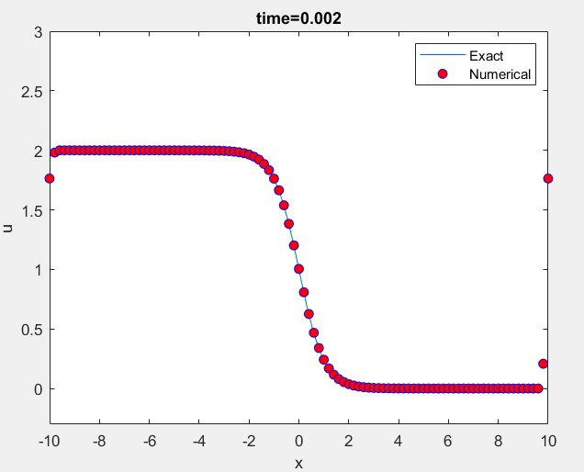

Figure 1: Analytical and Numerical solution of burgers equation at time $t=0.002$
- Analytical Solution of Burgers Equation using MATLAB

The MATLAB code used to generate the 2D and 3D plot of the Burgers solution obtained by travelling wave transformation method is shown below:

clc;
close all;
clear all;

% Domain and parameters
a = -10; b = 10;
V = 0.02;
h = 0.2;
x = a:h:b;
t = 0:0.1:1; % Time steps

% Preallocate the solution matrix
u_e = zeros(length(x), length(t));

% Compute the exact solution at all time steps
for n = 1:length(t)
u_e(:, n) = 1 - tanh(x - V * t(n));
end

% Create a figure with two subplots
figure;

% 1D plot (subplot 1)
subplot(1, 2, 1);
plot(x, u_e(:, end), 'LineWidth', 2);
xlabel('x');
ylabel('u');
%title();

% 3D plot (subplot 2)
[X, T] = meshgrid(x, t); % Meshgrid for plotting
subplot(1, 2, 2);
surf(X, T, u_e', 'EdgeColor', 'none'); % Transpose u_e to match dimensions
colormap('jet');
colorbar;
xlabel('x');
ylabel('Time (t)');
zlabel('u');
%title();
view(45, 30); % Adjust the view angle

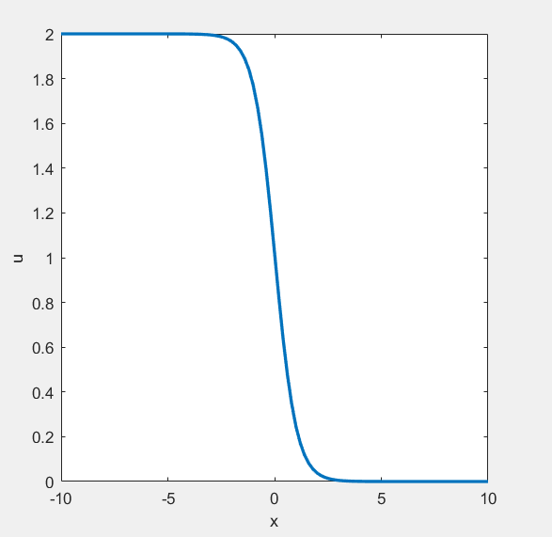
(a)
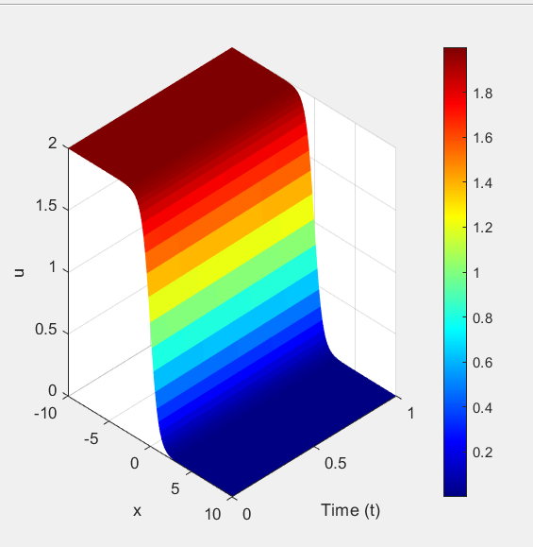
(b)
Figure 2: Analytical solution of Burgers equation for $Φ_{A}$= 1, V=.002 (a) in
two dimensions (b) in three dimensions.

- Numerical Solution of Burgers Equation using MATLAB
clear; clc;
% Parameters
nx = 101; nt = 1000; x_start = 0.0; x_end = 2.0; nu = 0.07;
dx = (x_end - x_start) / (nx - 1); dt = 0.001;
x = linspace(x_start, x_end, nx); t = linspace(0, nt*dt, nt+1);
% Stability check
if dt > min(dx / 1.0, dx^2 / (2 * nu)), error('dt is too large for stability.'); end
% Initial condition and boundary conditions
u = sin(pi * x); u([1, end]) = 0;
% Preallocate solution history matrix
u_history = zeros(nt+1, nx); u_history(1, :) = u;
% Time-stepping loop
for n = 1:nt
un = u; % Copy of current u
% Update u using explicit FDM (convection + diffusion terms)
for i = 2:nx-1
convection = un(i) * (un(i+1) - un(i-1)) / (2 * dx);
diffusion = nu * (un(i+1) - 2*un(i) + un(i-1)) / dx^2;
u(i) = un(i) - dt * convection + dt * diffusion;
end
u([1, end]) = 0; % Apply boundary conditions
u_history(n+1, :) = u;
end
% Create meshgrid for plotting
[T, X] = meshgrid(t, x);
U = u_history'
% Plot 3D surface
figure('Color', 'w', 'Position', [100, 100, 1000, 600]);
surf(X, T, U, 'EdgeColor', 'none');
view(45, 30); colormap jet; colorbar;
title('3D Surface Plot of Burgers'' Equation', 'FontSize', 14);
xlabel('Spatial Domain x', 'FontSize', 12); ylabel('Time t', 'FontSize', 12);
zlabel('Solution u', 'FontSize', 12); grid on;
% Plot 3D mesh
figure('Color', 'w', 'Position', [150, 150, 1000, 600]);
mesh(X, T, U); view(45, 30); colormap jet; colorbar;
title('3D Mesh Plot of Burgers'' Equation', 'FontSize', 14);
xlabel('Spatial Domain x', 'FontSize', 12); ylabel('Time t', 'FontSize', 12);
zlabel('Solution u', 'FontSize', 12); grid on;
% 1D plots at specific time steps
figure('Color', 'w', 'Position', [200, 200, 1000, 600]);
hold on; grid on;
plot_indices = [1, round(nt/4), round(nt/2), nt]; % Time steps to plot
colors = lines(length(plot_indices)); % Generate distinct colors
for k = 1:length(plot_indices)
plot(x, u_history(plot_indices(k), :), 'LineWidth', 2, 'Color', colors(k, :));
legend_entries{k} = sprintf('t = %.3f', t(plot_indices(k))); %#ok<SAGROW>
end
title('1D Solution of Burgers'' Equation at Different Times', 'FontSize', 14);
xlabel('Spatial Domain x', 'FontSize', 12); ylabel('Solution u', 'FontSize', 12);
legend(legend_entries, 'FontSize', 12, 'Location', 'Best');
hold off;
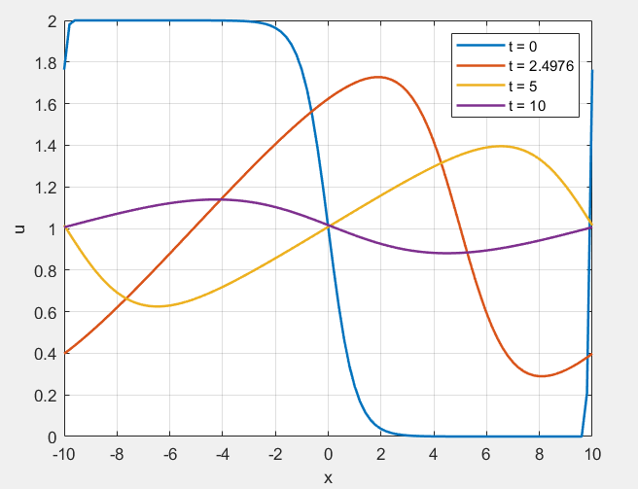
(a)
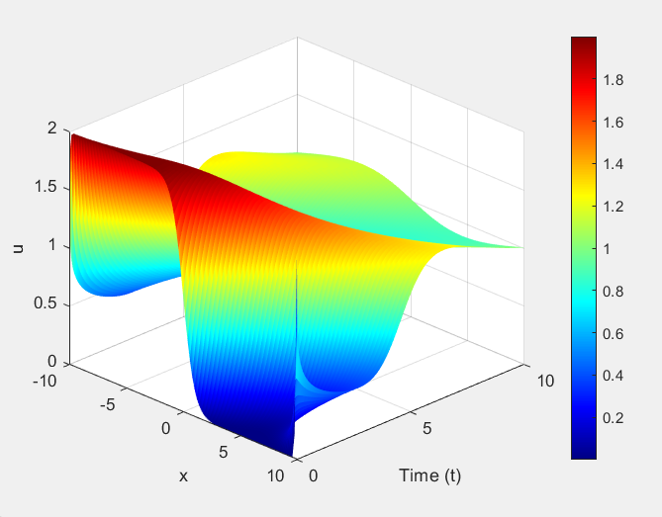
(b)
Figure 3: Numerical solution of Burgers equation (a) in two dimensions (b) in three dimensions.

- Results and discussion
This section presents an analysis of the results obtained from both the analytical and numerical solutions of Burgers' equation. The exact solution is derived using the Travelling Wave Transformation (TWT), while the numerical approximation is obtained through the Explicit Finite Difference Method (FDM). The discussion highlights the accuracy of the numerical approach, the evolution of the solution over time, and the comparison between the analytical and numerical results.
To assess the reliability of the numerical method, Figure 1 displays a comparison between the exact solution and the numerical approximation at $t=.002$The blue curve represents the analytical solution, whereas the red dots indicate the numerical results obtained via explicit FDM. The numerical solution closely follows the exact solution, confirming the capability of the finite difference method in capturing the wave structure. Nevertheless, minor deviations appear, especially in regions with steep gradients. These discrepancies can be attributed to numerical dissipation and dispersion errors, which are commonly encountered in explicit finite difference schemes when approximating sharp wave fronts.
Figure 2 illustrates the exact solution of Burgers' equation, derived using the Travelling Wave Transformation, at$t=1$. The graph depicts a smooth shock wave structure, which is characteristic of Burgers' equation with viscosity. The nonlinear term steepens the wave, while the diffusion term acts to smooth it out. The solution transitions distinctly from a higher to a lower value, confirming the presence of a traveling wave. This validates the effectiveness of TWT in accurately representing the analytical behavior of the problem.
The numerical solution's temporal evolution is depicted in Figure 3, illustrating how the solution changes over different time steps$\left(t=0,2.4976,5 and 10\right)$. At $t=0$, the solution initially exhibits a discontinuous, step-like profile. As time advances, the wave structure gradually smooths due to the combined effects of viscosity and nonlinear wave propagation. At intermediate time steps, the solution forms a nonlinear wave with noticeable oscillations. By$t=0$, the wave has significantly diffused, resulting in a smoother profile, demonstrating the well-known behavior of Burgers' equation in modeling shock wave development and dissipation.
The numerical simulations indicate that explicit FDM provides an effective approximation of the exact solution, particularly for small time steps. However, since it is conditionally stable, the choice of time step size ($Δt$) is crucial to avoid numerical instabilities.

- Concluding Remarks
The comparison between analytical and numerical results demonstrates that the explicit finite difference method offers a precise and stable solution to Burgers’ equation. The numerical approximation closely aligns with the exact solution, exhibiting minimal error and confirming the method’s reliability. This study highlights the effectiveness of numerical techniques in solving nonlinear partial differential equations (PDEs) and reinforces the crucial role of Burgers’ equation in modeling real-world physical phenomena.

Moreover, the findings emphasize the need for carefully selecting numerical schemes to achieve a balance between accuracy, stability, and computational efficiency. While the explicit finite difference method proves to be a viable approach, further exploration of alternative methods, such as implicit schemes or spectral techniques, could enhance both accuracy and efficiency, especially for high Reynolds number flows.

Additionally, this study underscores the broader relevance of Burgers’ equation across multiple scientific and engineering fields, including fluid dynamics, traffic flow modeling, and shock wave analysis. Future research could extend the current numerical framework to higher-dimensional problems or incorporate advanced computational techniques like adaptive mesh refinement to enhance performance and precision.

In conclusion, this work highlights the essential role of numerical simulations in gaining insights into complex physical systems and provides a strong foundation for future developments in computational fluid dynamics and nonlinear PDEs.

- References

[1] | J. M. Burgers, A mathematical model illustrating the theory of turbulence. Advances in Applied Mechanics, 1948, pp. 171-199.
[2] | R. J. LeVeque, Finite Difference Methods for Ordinary and Partial Differential Equations: Steady-State and Time-Dependent Problems. Society for Industrial and Applied Mathematics (SIAM)., 2007.
[3] | E. Hopf, The partial differential equation $u_{t}+uu_{x}=μu_{xx}$. Communications on Pure and Applied Mathematics, 1950, pp. 201-230.
[4] | J. W. Thomas, 4. Thomas, J. W. (1995). Numerical Partial Differential Equations: Finite Difference Methods. Springer., 1995.
[5] | Y. &. X. X. Zhang, Numerical methods for solving the Burgers equation using finite differences. Computational and Applied Mathematics, 2012, pp. 267-286.
[6] | J. D. Cole, On a quasi-linear parabolic equation occurring in aerodynamics. Quarterly of Applied Mathematic, 1951, pp. 225-236.
[7] | R. J. LeVeque, Numerical Methods for Conservation Laws. Birkhäuser., 1992.
[8] | P. D. &. W. B. Lax, Systems of conservation laws. Communications on Pure and Applied Mathematics, 1960, pp. 217-237.
[9] | C. A. J. Fletcher, Computational Techniques for Fluid Dynamics. Springer, 1988.

